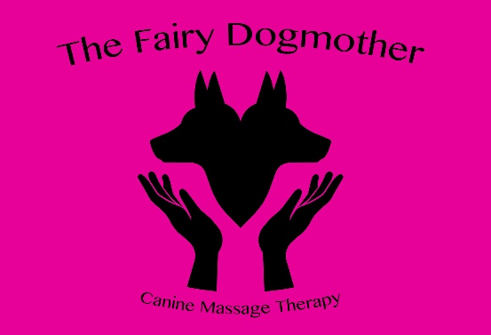 | Clinical Canine Massage Veterinary Consent Form | 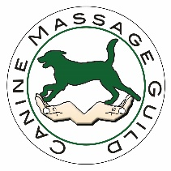
Zoe Manterfield
1 The Gordons Girling Street, Sudbury, Suffolk, CO10 1NB
Telephone: 07764801681
Email: zmanterfield@hotmail.co.uk
Web: www.thefairydogmother.eu

Please return to the above details when completed.
Owners Name
Address
 |  |  |  |  | Postcode
Email
Phone Number
Mobile Number
Dogs Details
Name |  |  | Breed |  |  | Sex
DOB |  |  | Colour |  |  | Nuetered
I declare I am the legal owner of the above named dog and that all information presented is correct to the best of my knowledge. I give consent for my dog to have massage therapy by Zoe Manterfield, The Fairy Dogmother, insured with Balens.
Owners Signature:………………………………Print Name:………………………………….Date: …………….

Veterinary Surgery

Address, Telephone
Number, Practice Stamp

YOUR VET MUST COMPLETE THIS AREA ALONG WITH A SIGNATURE
Reason for approach, treatment and area of concern
Is the dog on medication? If so, please provide details.

In your opinion is the above named dog in a suitable state of health to undergo massage therapy? YES/NO
Signature of Veterinarian:……………………………………………………. Date:……………….

